University of BalochistanPakistan

**CERTIFICATION**

I was held responsible for managing the Amazon US Market at Washington and UAE Amazon. I also managed to lead the job in Amazon or Daraz around. Being a Blogger I am managing my own website [www.JobsInBalochistan.com](http://www.JobsInBalochistan.com) with perfect SEO.

**Virtual Assistant and SEO & Blogging**

**VA Amazon & Daraz Market | March 2020 - present**

**EXPERIENCE**

**Experience 2022**

**SEO & Blogging**

* Digi Skill board Certified Freelancer Specialist (DiGiCFS)
* The DiGI Program has validated me as the Freelancer in the advance knowledge and experience to improve Accounts.
* Space and Upper Atmosphere Research Commission SUPERCO Karachi
* Microsoft Office
* Basic Course and Road Safety Commission NHMP Federal
* Virtual Assistant From Enablers
* SEO and Blogging

I have been running my own E-Commerce Business for 3 years, withmy most recent experience being a Virtual Assistant & SEO Blogger. I possess valuable skills such as conﬁdence and Honesty that I believe make me best suited for the Position of Freelancer in a company because of my skills being mentioned below.

**INTERPERSONAL SKILLS**

1. Attention to detail.

5. Good interpersonal skills

4. Ability to operate Clients counting machines.

3. Strong math and science skills.

2. Computer literacy.

Some of my interpersonal skills include the following:

**HIGH SCHOOL**

**BACHELOR IN GEOGRAPHY**

Turbat, Balochistan, Pak

Instagram.com/malialblushi

Twitter.com/sameerbaloch450

Facebook.com/sameershah450

**SEO & Blogging | VA**

**Virtual Assistant | SEO & Blogging**

**SECONDARY HIGH SCHOOL**

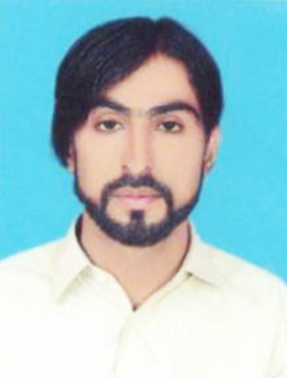

+92-321-1233450

Mubarak.bezinjo@gmail.com

perry@email.com

8100 34 5005

SEO & Blogging

Email: Not Available

0852 41 2400

KU and Govt E-Commerce

Absor Turbat High School

Turbat Mekran, Balochistan

2009 - 2013

Atta Shad Degree College

Turbat Kech, Balochistan

2014 - 2016

University of KarachiPakistan

2017 - 2019

**Master in English Literature**

2020 - 2023

**HR Manager**

**Mrs. Aheesha**

**Head Freelancing in Pak**

**Sir Hasham Sarwar**

**REFERENCE**

**OBJECTIVE**

**MUBARAK ALI**