University of Balochistan
Pakistan
CERTIFICATION
I was held responsible for managing the Amazon US Market at Washington and UAE Amazon. I also managed to lead the job
in Amazon or Daraz around. Being a Blogger I am managing my own website www.JobsInBalochistan.com with perfect SEO.
Virtual Assistant and SEO & Blogging
VA Amazon & Daraz Market | March 2020 - present
EXPERIENCE
Experience 2022
SEO & Blogging
- Digi Skill board Certified Freelancer Specialist (DiGiCFS)
- The DiGI Program has validated me as the Freelancer in the advance knowledge and experience to improve Accounts.
- Space and Upper Atmosphere Research Commission SUPERCO Karachi
- Microsoft Office
- Basic Course and Road Safety Commission NHMP Federal
- Virtual Assistant From Enablers
- SEO and Blogging
I have been running my own E-Commerce Business for 3 years, with
my most recent experience being a Virtual Assistant & SEO Blogger. I possess valuable skills such as conﬁdence and Honesty that I believe make me best suited for the Position of Freelancer in a company because of my skills being mentioned below.
INTERPERSONAL SKILLS
1. Attention to detail.
5. Good interpersonal skills
4. Ability to operate Clients counting machines.
3. Strong math and science skills.
2. Computer literacy.
Some of my interpersonal skills include the following:
HIGH SCHOOL
BACHELOR IN GEOGRAPHY
Turbat, Balochistan, Pak
Instagram.com/malialblushi
Twitter.com/sameerbaloch450
Facebook.com/sameershah450
SEO & Blogging | VA
Virtual Assistant | SEO & Blogging
SECONDARY HIGH SCHOOL
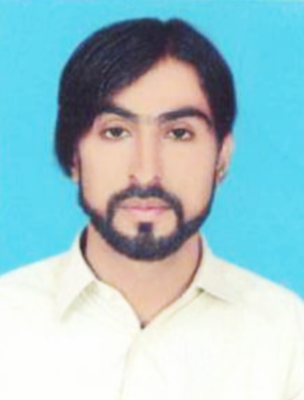
+92-321-1233450
Mubarak.bezinjo@gmail.com
perry@email.com
8100 34 5005
SEO & Blogging
Email: Not Available
0852 41 2400
KU and Govt E-Commerce
Absor Turbat High School
Turbat Mekran, Balochistan
2009 - 2013
Atta Shad Degree College
Turbat Kech, Balochistan
2014 - 2016
University of Karachi
Pakistan
2017 - 2019
Master in English Literature
2020 - 2023
HR Manager
Mrs. Aheesha
Head Freelancing in Pak
Sir Hasham Sarwar
REFERENCE
OBJECTIVE
MUBARAK ALI

